**How to get email notification from github “when push is happened”**

1. Select repo -> click on settings -> click on notifications -> add email address

**How to get email notification from Jenkins without respect of build result**

**Conditions:**

You mentioning email in SMTP

1. Should not have 2-way authentication
2. It should allow “low secure apps” it should be ON
3. If any error “captcha should off”
4. Log in into Jenkins server -> click on Manage Jenkins -> click on Manage Plugin -> install “**Mailer plugin” and “Email Extension Plugin” ->** then click on Manage Jenkins -> go to “configure system” -> go to “Email Notification” and SMTP server details and also

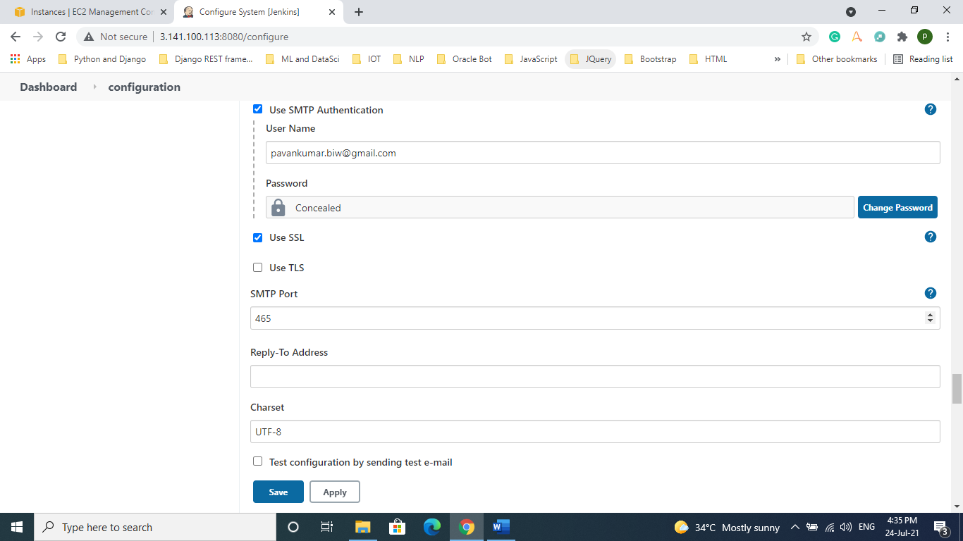

1. Click on “apply and save”
2. Create a new job or exiting job -> go to post build actions and choice “editable email notification”

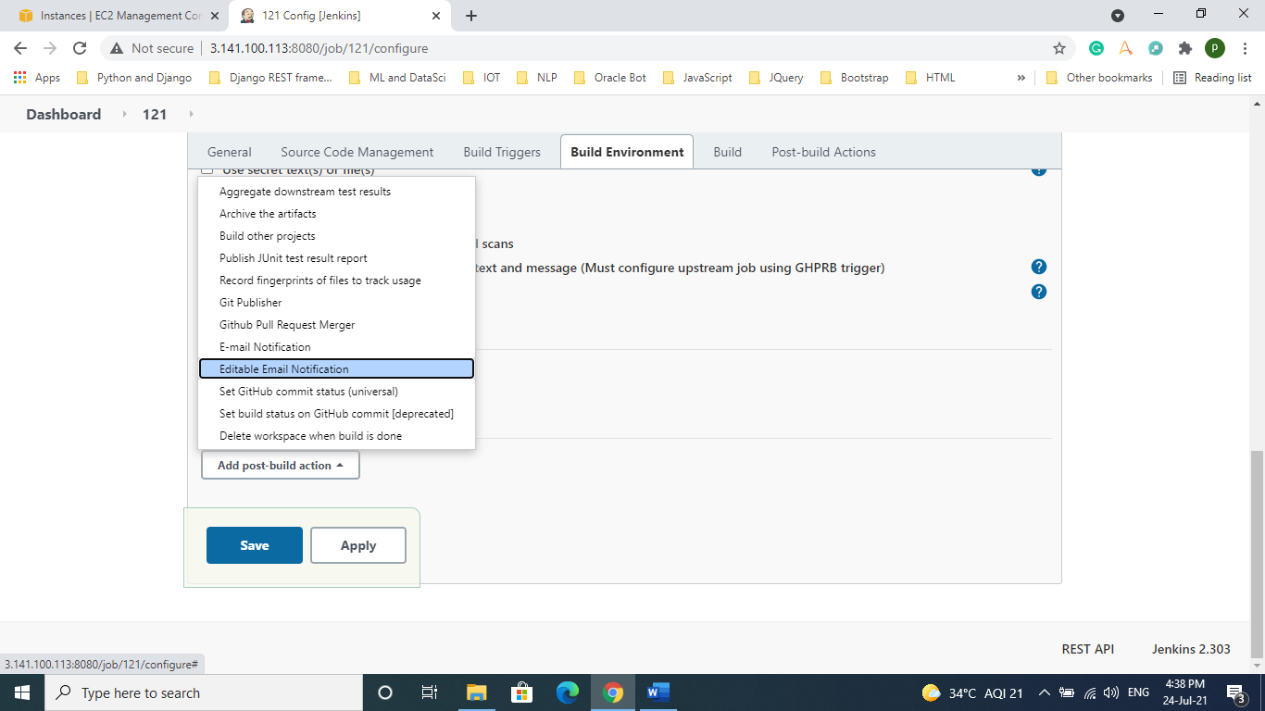

1. A new form appeared select attach build Log and click on advanced settings.

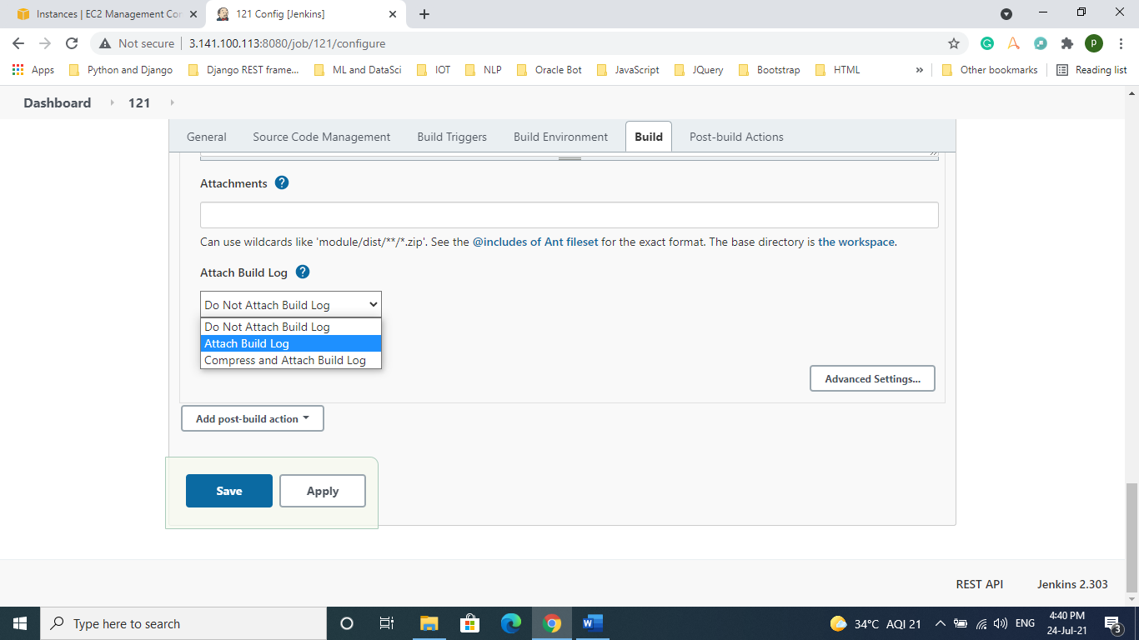

1. Choice targets

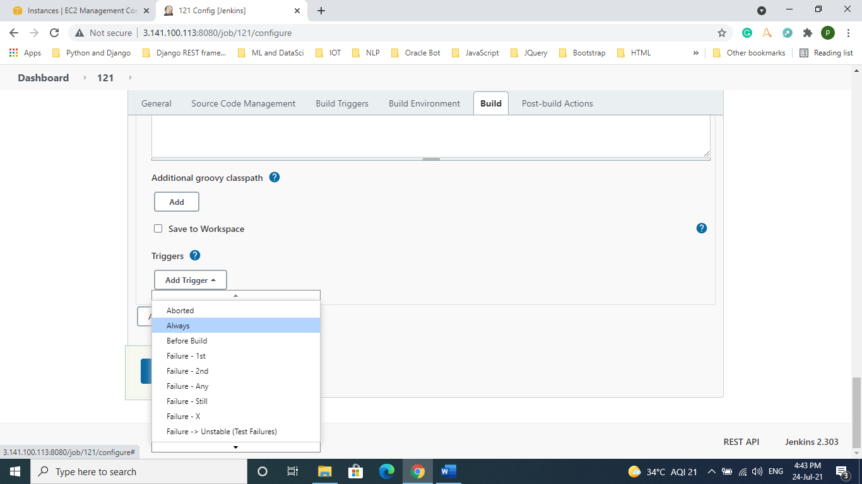

1. Select developers list or recipient list

Make sure you need to add “email address in recipient list” other wise it will take default emails.

